American Heart Association Upcoming 2024 Classes
Held at Sanilac Medical Services Classroom
Register for each class via email aherek@sanilacmca.org or calling the office at 810-648-3092
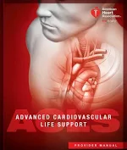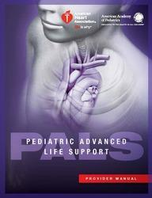

ACLS Update/Heartcode 8:30-12:30 | PALS Update/Heartcode 12:30-4:30
 | March 22, 2024 9am to …..
September 09,2024 8:30-12:30 | September 09,2024 12:30-4:30
December 11,2024  8:30-12:30 | December 11,2024  12:30-4:30
2025 Dates to be determined | 2025 Dates to be determined
Updated 2020 books are available at each of the area Hospitals and EMS agencies, you may also contact us at Medical Control to obtain the new version.
Anyone that is in need of the Full course for ACLS or PALS will complete the heartcode online version on the eheartleaning. com website and will present on the respective date with the completion certificate.
Update Students will do all the Pre Course work and Pre Test prior to the course date.

