“Patient Information Sticker”
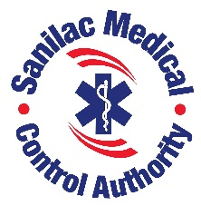

EMS Narcan Leave-Behind Replacement Form

Date: ______________

Narcan to be replaced by SMCA office. Please bring completed form to 171 Dawson St. Ste 238 for restocking.
Patient Name: ________________________________ DOB: ______________Incident #: _____________
Bag # Left Behind: _________ _________ New Bag #: _________ __________
Medications Used: (Please Print) | Dosage: | Route: | Time given:

Paramedic Name: ________________________ Paramedic Signature: ____________________
EMS Agency & Unit #: _____________________

Form effective April 21, 2022.
Lea Lentz, BS, NRP, IC
Executive Director
Sanilac Medical Control Authority.

Revised April 2022.

