Naloxone Medication Kit Contents and Distribution Procedure

- Medications and supplies for naloxone kits will be supplied by Medical Control Authority.
- Assembly, labeling, and access to kits will be done according to the Pharmacy, Drug Box and IV Supply Exchange Procedure.
- Overdose Medication Kit Contents List

Medication / Item | Concentration | Packaging | Quantity
Naloxone (Narcan) | 4mg / spray | Nasal Spray | 1
MDHHS Safety Advice for Patient and Family Members Card |  |  | 1
Replacement Form |  |  | 1
Local Treatment Resources Form |  |  | 1

- Procedure
- Each participating EMS Agency will stock each of its licensed vehicles with 2 Naloxone Medication Kits.
  - Each participating EMS Agency will receive a cache of kits, provided by the Medical Control Authority, to re-supply each licensed vehicle
- After deployment, the naloxone medication kit will be replaced within 24 hours from the agency cache, or
  - By contacting the MCA to arrange delivery
- Kits will be stored on the EMS vehicle in a secure way, not accessible to the public.
- Kits in the agency cache will be securely stored as they would with un-assigned drug boxes
- Deployment of a Naloxone Medication Kit will be documented in the patient care record and uploaded to the Michigan EMS Information System.
  - In the medication delivered list, choose “Nasal Naloxone” if a kit is left behind
  - In the narrative document either “naloxone kit offered and accepted” or “naloxone kit offered and refused”.
- The replacement/use form will be completed, gathered by the agency EMS Coordinator/Supervisor and given to the MCA upon delivery of replacement kits.
  - The PCR number MUST be documented on the exchange form to allow for data collection and tracking.
INSTRUCTION INSERT: Side 1
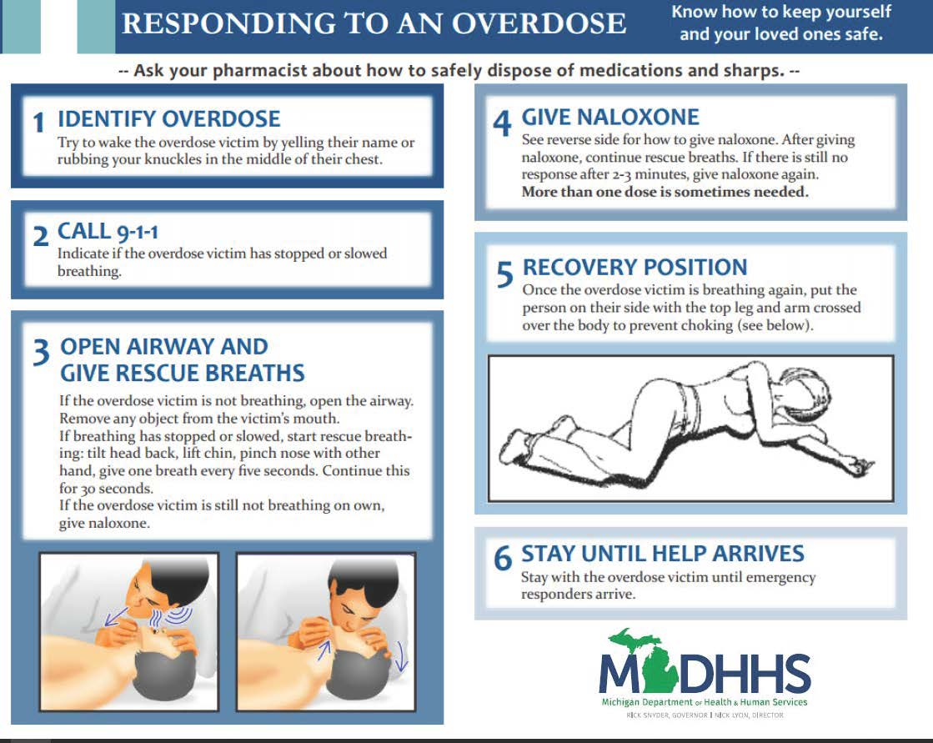

INSTRUCTION INSERT: Side 2
