MFR & Basic EMT-Epinephrine Study
Pediatric Bronchospasm

Pre-Medical Control:
MFR/EMT/SPECIALIST/PARAMEDIC
- Follow Pediatric Assessment and Treatment Protocol.
- Assist the patient in using their own Albuterol Inhaler, if available

EMT/SPECIALIST
- Albuterol may be indicated. Refer to Nebulized Bronchodilators Procedure.
- Consider CPAP, if available, per CPAP/BiPAP Procedure.

MFR/EMT/SPECIALIST/PARAMEDIC
- In cases of severe respiratory distress/failure:
a. If child weighs less than 10 kg (approx. 20 lbs.), contact medical control prior to Epinephrine if possible.
b. If child weighs between 10-30 kg (approx. 60 lbs.), administer Epinephrine 1:1000 - 1 mg/mL, 0.15 mg (0.15 ml) IM OR via pediatric Epinephrine auto-injector.
c. If child weighs greater than 30 kg, administer Epinephrine 1:1000 - 1 mg/mL, 0.3 mg (0.3 ml) IM OR via Epinephrine auto-injector.

PARAMEDIC
- Per MCA selection, administer Bronchodilator per Nebulized Bronchodilators Procedure.
- Per MCA selection, if a second nebulized treatment is needed also administer Prednisone OR Methylprednisolone.

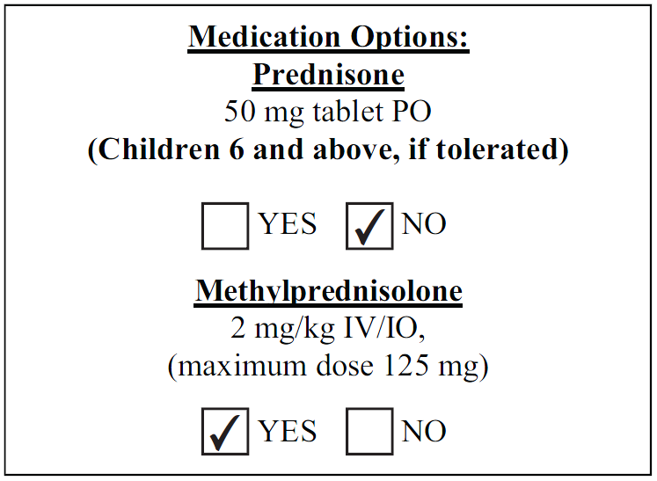

- Consider CPAP/BiPAP (if available) per CPAP/BiPAP Procedure.

Post-Medical Control:
MFR/EMT/SPECIALIST/PARAMEDIC
- Additional Epinephrine IM:
a. If child weighs between 10-30 kg (approx. 60 lbs.), administer
Epinephrine 1:1000 - 1 mg/mL, 0.15 mg (0.15 ml) IM OR via pediatric epinephrine auto-injector.
b. If child weighs greater than 30 kg, administer Epinephrine 1:1000 - 1 mg/mL 0.3 mg (0.3 ml) IM OR via adult epinephrine auto-injector.

