MFR & Basic EMT-Epinephrine Study
Pediatric Anaphylaxis/Allergic Reaction

Pre-Medical Control
MFR/EMT/SPECIALIST/PARAMEDIC
- Follow Pediatric Assessment and Treatment Protocol.
- Determine substance or source of exposure, remove patient from source if known and able.
- Assist the patient in administration of their own epinephrine auto-injector, if available.

MFR/EMT/SPECIALIST/PARAMEDIC
- In cases of severe allergic reaction, wheezing or hypotension:
a. If child weighs less than 10 kg (approx. 20 lbs.), contact medical control prior to Epinephrine if possible.
b. If child weighs between 10-30 kg (approx. 60 lbs.), administer Epinephrine 1:1000 - 1 mg/mL, 0.15 mg (0.15 ml) IM OR via pediatric epinephrine auto-injector.
c. If child weighs greater than 30 kg, administer Epinephrine 1:1000 - 1 mg/mL 0.3 mg (0.3 ml) IM OR via adult epinephrine auto-injector.

EMT/SPECIALIST/PARAMEDIC
- Albuterol may be indicated. Refer to Nebulized Bronchodilators Procedure.

PARAMEDIC
- In cases of profound anaphylactic shock (near cardiac arrest), administer Epinephrine 1:10,000 - 0.1 mg/mL, 0.01 mg/kg (0.1 ml/kg) slow IV/IO to a maximum of 0.3 mg (3 ml).
- If patient is symptomatic, administer diphenhydramine 1 mg/kg IM/IV/IO (maximum dose 50 mg).
- Per MCA selection, administer Bronchodilator per Nebulized Bronchodilators Procedure.

- Per MCA Selection administer Prednisone OR Methylprednisolone.

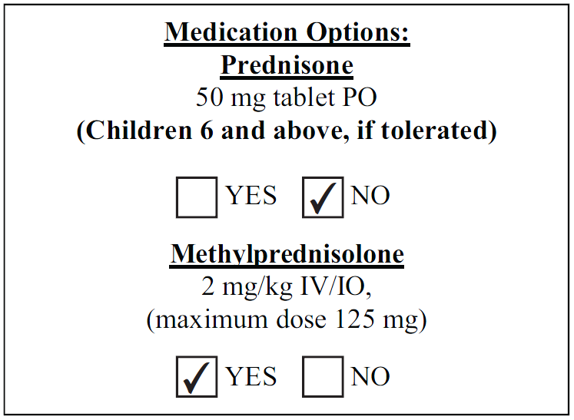

Post-Medical Control:
MFR/EMT/SPECIALIST/PARAMEDIC
- Additional Epinephrine IM:
a. If child weighs between 10-30 kg (approx. 60 lbs.), administer Epinephrine 1:1000 - 1 mg/mL, 0.15 mg (0.15 ml) IM OR via pediatric epinephrine auto-injector.
b. If child weighs greater than 30 kg, administer Epinephrine 1:1000 - 1 mg/mL 0.3 mg (0.3 ml) IM OR via adult epinephrine auto-injector.

PARAMEDIC
- Consider additional Epinephrine IV/IO:
a. In cases of profound anaphylactic shock (near cardiac arrest), administer Epinephrine 1:10,000 - 0.1 mg/mL, 0.01 mg/kg (0.1 ml/kg) slow IV/IO to a maximum of 0.3 mg (3 ml).

