MFR & Basic EMT-Epinephrine Study
Respiratory Distress

Pre-Medical Control
MFR/EMT/SPECIALIST/PARAMEDIC
- Follow General Pre-hospital Care Protocol.
- Allow patient a position of comfort.
- Determine the type of respiratory problem involved:

STRIDOR/UPPER AIRWAY OBSTRUCTION:
MFR/EMT/SPECIALIST/PARAMEDIC
- Complete Obstruction:
a. Follow Emergency Airway Procedure.
- Partial Obstruction: epiglottitis, foreign body, anaphylaxis:
a. Follow Emergency Airway Procedure.
b. Consider anaphylaxis (see Anaphylaxis/Allergic Reaction Protocol).
c. Transport in position of comfort.

CLEAR BREATH SOUNDS:
PARAMEDIC
- Possible hyperventilation, metabolic problems, MI, pulmonary embolus
  - Obtain 12-lead ECG, if available.

CRACKLES (CHF/PULMONARY EDEMA):
MFR/EMT/SPECIALIST/PARAMEDIC
- Refer to the Pulmonary Edema/CHF protocol in the adult cardiac protocols.

RHONCHI (SUSPECTED PNEUMONIA):
MFR/EMT/SPECIALIST/PARAMEDIC
- Sit patient upright.
EMT/SPECIALIST
- Consider CPAP per MCA selection. Refer to CPAP/BiPAP Procedure.
SPECIALIST
- Consider NS IV/IO fluid bolus up to 1 liter, wide open if tachycardia, repeat as needed.
PARAMEDIC
- Consider CPAP/BiPAP (if available) per CPAP/BiPAP Procedure.
- Consider NS IV/IO fluid bolus up to 1 liter, wide open if tachycardia, repeat as needed.

ASYMETRICAL BREATH SOUNDS:
PARAMEDIC
- If evidence of tension pneumothorax and patient unstable, consider decompression (refer to Pleural Decompression Procedure)

WHEEZING, DIMINISHED BREATH SOUNDS (ASTHMA, COPD):
MFR/EMT/SPECIALIST/PARAMEDIC
- Assist the patient in using their own Albuterol Inhaler, if available.
- Administer Epinephrine 1:1000 - 1 mg/mL, 0.3 mg (0.3 ml) IM to patients with impending respiratory failure unable to tolerate nebulizer therapy.
EMT/SPECIALIST
- Administer Albuterol if available. Refer to Nebulized Bronchodilators Procedure.
- Consider CPAP (if available). Refer to CPAP/BiPAP Procedure.
PARAMEDIC
- Administer Bronchodilator per Nebulized Bronchodilators Procedure.
- Per MCA Selection, if a second nebulized treatment is needed, administer Prednisone OR Methylprednisolone.

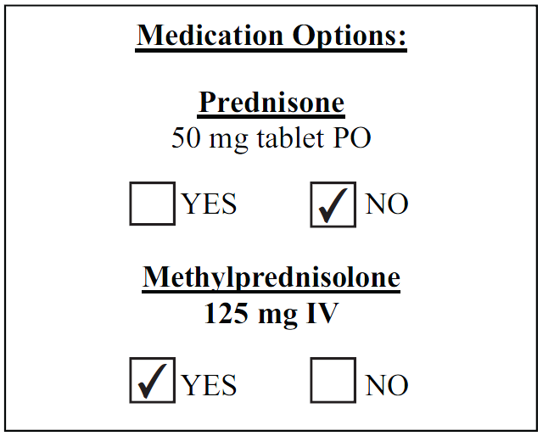

- Consider CPAP/BiPAP (if available) per CPAP/BiPAP Procedure.

Post -Medical Control

ASTHMA:
MFR/EMT/SPECIALIST/PARAMEDIC
- Consider Epinephrine 1:1000 - 1 mg/mL, 0.3 mg (0.3 ml) IM in patients with impending respiratory failure unable to tolerate nebulizer therapy.
PARAMEDIC
- Consider Magnesium Sulfate 2 gm slowly IV in refractory Status Asthmaticus. Administration of Magnesium Sulfate is best accomplished by adding Magnesium Sulfate 2 gm to 100 to 250 ml of NS and infusing over approximately 10 minutes.

