MFR & Basic EMT-Epinephrine Study
Anaphylaxis/Allergic Reaction

Pre-Medical Control
MFR/EMT/SPECIALIST/PARAMEDIC
- Follow General Pre-Hospital Care Protocol.
- Determine substance or source of exposure, remove patient from source if known and able.
- Assist patient administration of their epinephrine auto-injector, if available.

MFR/EMT/SPECIALIST
- In cases of severe allergic reaction, wheezing or hypotension, administer Epinephrine 1:1000 - 1 mg/mL 0.3 mg (0.3 ml) IM OR via adult epinephrine auto-injector.

EMT/SPECIALIST
- Albuterol may be indicated. Refer to Nebulized Bronchodilators Procedure.

SPECIALIST
- Administer a NS IV/IO fluid bolus up to 1 liter, wide open as indicated.

PARAMEDIC
- In cases of severe allergic reaction, wheezing or hypotension, administer Epinephrine 1:1000 - 1 mg/mL, 0.3 mg (0.3 ml) IM OR via auto-injector
- In cases of profound anaphylactic shock (near cardiac arrest), administer Epinephrine 1:1000 - 0.1 mg/mL, 0.3 mg (3 ml) slow IV/IO.
- Administer a NS IV/IO fluid bolus up to 1 liter, wide open as indicated.
- If patient is symptomatic, administer diphenhydramine 50 mg IM or IV/IO.
- Per MCA selection, administer Bronchodilator per Nebulized Bronchodilators Procedure.
- Per MCA selection, administer Prednisone OR Methylprednisolone.

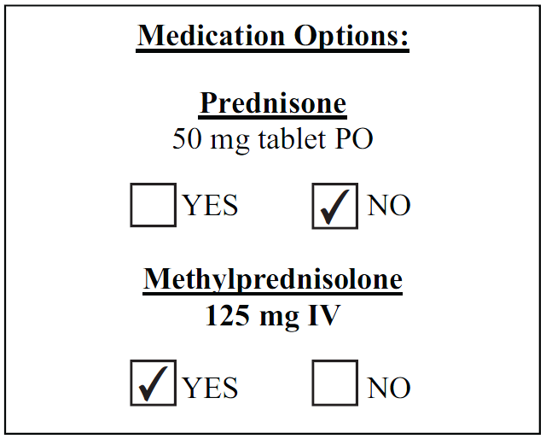
Post-Medical Control:
MFR/EMT/SPECIALIST/PARAMEDIC
- Additional Epinephrine IM:
  - Administer additional Epinephrine 1:1000 - 1 mg/mL, 0.3 mg (0.3 ml) IM OR via adult Epinephrine auto-injector.

PARAMEDIC
- Additional Epinephrine IV/IO:
  - Epinephrine 1:10,000 - 0.1 mg/mL 0.3 mg (3 ml) slow IV/IO if critically ill (near cardiac arrest).

